Part IV.Dynamic hedging
The insight behind the Black-Scholes formula for options valuation is the recognition that, if you know the future volatility of a stock, you can replicate an option payoff exactly by a continuous rebalancing of a portfolio consisting of the underlying stock and a risk-free bond.
The hedger now follows a Black-Scholes hedging strategy, rehedging at discrete, evenly spaced time intervals as the underlying stock changes. At expiration, the hedger delivers the option payoff to the option holder, and unwinds the hedge. We are interested in understanding the final profit or loss of this strategy:
Final profit&loss = Value of Black-Scholes hedge at T -Final option payoff
If the hedger had followed the exact Black-Scholes replication strategy, rehedging continuously as the underlying stock evolved towards its final value at expiration, then, no matter what path the stock took, the final P&L would be exactly zero. This is the essence of the statement that the Black-Scholes formula provides the ‘‘fair’’ value of the option.
When the replication strategy deviates from the exact Black-Scholes method, the final P&L may deviate from zero. This deviation is called the replication error
However, in many cases, our hedge is not perfect, which means that there will be replication errors, which are sometimes conducive to profit and loss, and sometimes not conducive to profit and loss.
To test the range, we ran 50000 random paths by same hedging strategy. We assume a volatility of 20% and a discount rate of 5%, and we make N rehedging trades evenly spaced throughout the life of the Black-Scholes model.
First we choose N=21, and here is its profit and loss histogram
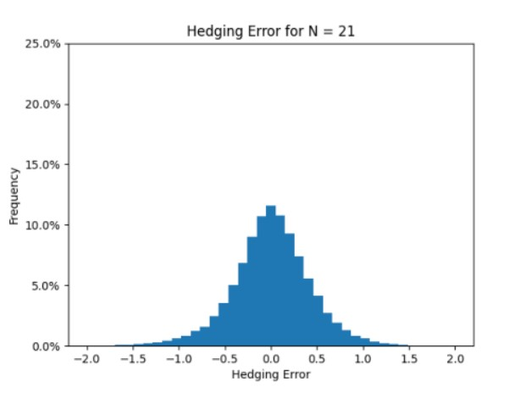

Second we choose N=84, and here is its profit and loss histogram.
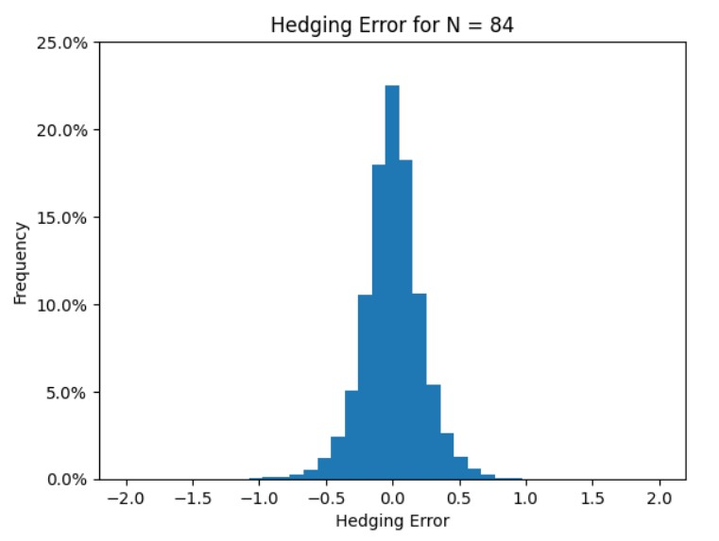
To make this more intuitive, I've created a chart to show statistical summary of the simulated profit/loss.
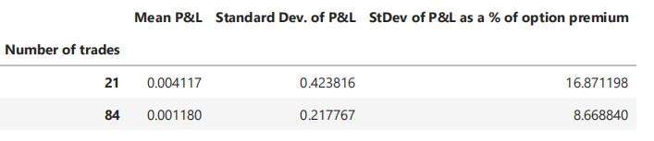

We can summarize the following conclusions: First, within the statistical error range of the simulation, the average profit and loss is 0. Second, more frequent hedging will reduce the standard deviation of the final profit and loss, as shown in the table above, as part of the option premium, when N=21, the standard deviation is 16.871, while when N=84, the standard deviation is only 8.667, which is nearly half lower than that of N=21.
So we can conclude that the relationship between the frequency of rebalancing in hedging trading strategies and the final profit and loss standard deviation typically indicates that as the frequency of rebalancing increases, the standard deviation of the final profit and loss decreases.

